

LAB EXPERIMENT RECORD

SET 15
Department | Artificial Intelligence and Data Science
Course Code / Course Name | DSA0601 / Data Handling and Visualization
Name / Register Number | K.L Dinesh Eshwar / 192425027
Date / Day | 08/10/2026

Aim
To analyze product sales analysis using the requested visualizations and dashboard views.

Dataset
Product Sales Analysis
Product_ID | Product_Name | January_Sales | February_Sales | March_Sales
1 | Product A | 2000 | 2200 | 2400
2 | Product B | 1500 | 1800 | 1600
3 | Product C | 1200 | 1400 | 1100

R Data Setup
Run this setup once before the R programs below. The dataset is defined inline so each record can be copied and run without a separate CSV file.
R data setup
dat <- data.frame(
Product_ID = c(1, 2, 3),
Product_Name = c("Product A", "Product B", "Product C"),
January_Sales = c(2000, 1500, 1200),
February_Sales = c(2200, 1800, 1400),
March_Sales = c(2400, 1600, 1100)
)

PROGRAM 1: Grouped Bar Chart of Product Sales
Create a grouped bar chart comparing the first-quarter monthly sales for each product.
R code
sales <- as.matrix(dat[c("January_Sales","February_Sales","March_Sales")])
barplot(t(sales), beside=TRUE, names.arg=dat$Product_Name, col=c("#276B9A","#1D8790","#E68A36"), legend=TRUE, xlab="Product", ylab="Sales ($)", main="Quarter 1 Sales by Product")

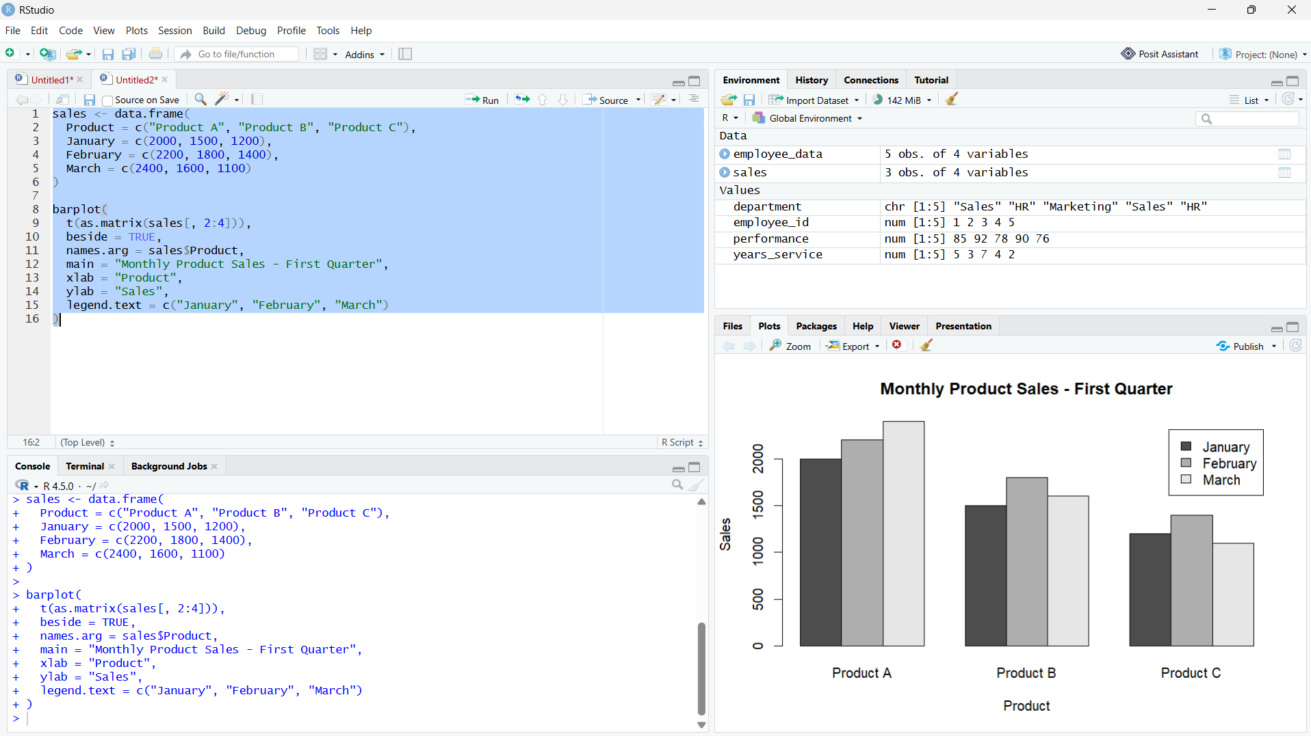
Output 1: Grouped Bar Chart of Product Sales
Observation: Product A leads sales in all three months; February is the strongest month overall.

PROGRAM 2: Stacked Area Chart of Monthly Sales
Create a stacked area chart showing total sales by product over the three months.
R code
library(ggplot2)
long <- reshape(dat, varying=c("January_Sales","February_Sales","March_Sales"), v.names="Sales", timevar="Month", times=c("January","February","March"), direction="long")
ggplot(long, aes(Month, Sales, fill=Product_Name)) + geom_area() + labs(title="Monthly Sales by Product", x="Month", y="Sales ($)") + theme_minimal()

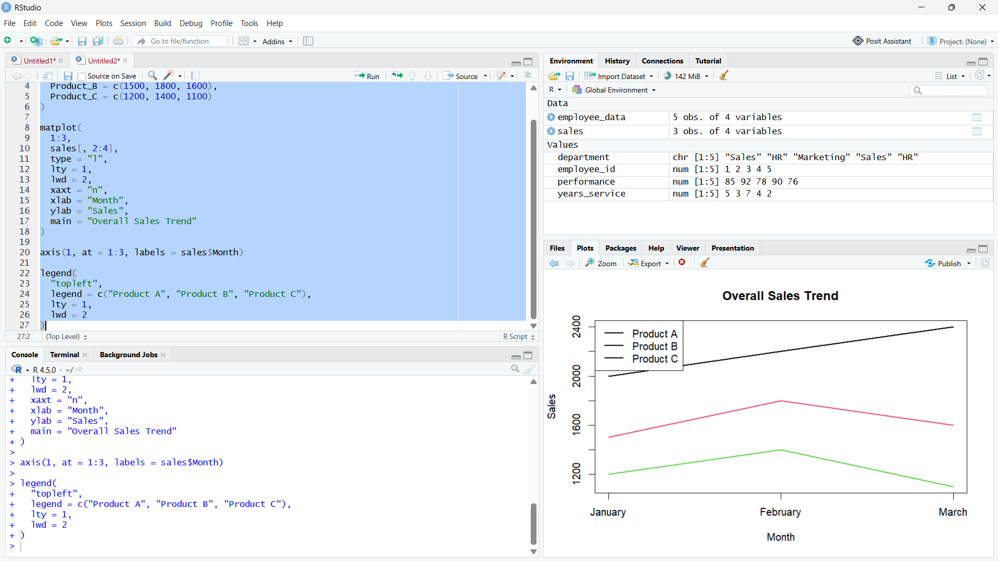
Output 2: Stacked Area Chart of Monthly Sales
Observation: Combined sales increase from January to February, then rise slightly in March; Product A is the largest contributor.

PROGRAM 3: Monthly Product Sales Table
Display the monthly sales data for each product in a labeled table.
R code
print(dat)

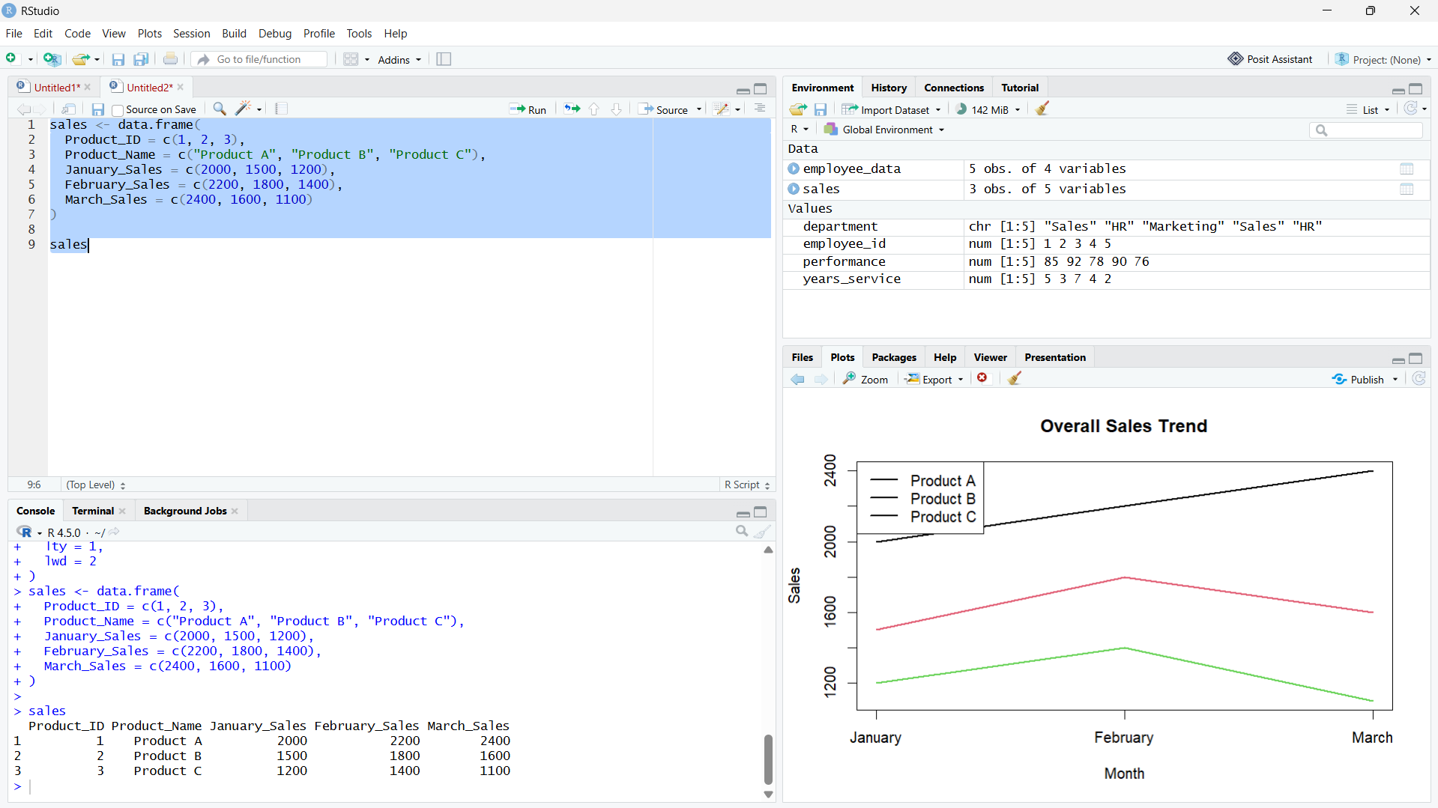

Output 3: Monthly Product Sales Table

Observation: The table preserves the supplied sales values for all three products and months.

PROGRAM 4: Product Sales Dashboard
Create an interactive Tableau dashboard with the grouped bar chart, stacked area chart, and data table.
Tableau build steps
Tableau dashboard build
1. Connect to the monthly product sales table.
2. Create a grouped bar view with Product_Name and the three month sales measures.
3. Create a stacked area view with Month and Product_Name.
4. Add a text table and place all three sheets on a dashboard.

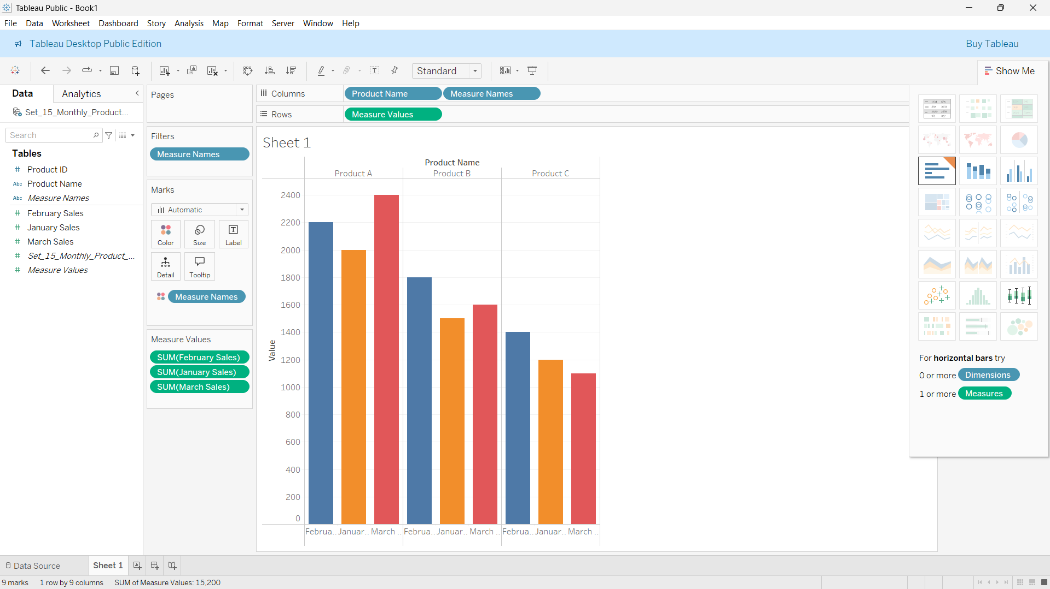

Output 4: Product Sales Dashboard

Observation: The preview places product comparisons beside the monthly composition and source table. Product selection can be used as a dashboard filter.

Procedure
1. Review the dataset table and confirm any illustrative fields noted in the record.
2. Run the R setup block once, then run the requested program code.
3. Compare the output screenshot with the observation and replace illustrative values when actual data is available.
4. For Tableau tasks, connect to the displayed data and follow the dashboard build steps.

Result
The requested charts and dashboard views for Set 15 were prepared from the displayed dataset. Outputs include labels, short observations, and code or dashboard construction steps.

Key Functions Used
plot(), barplot(), hist(), boxplot(), table().

